✈️ New for Travelers: Concur Expense Now Includes ExpenseIt. Available Now!!
We’re excited to introduce ExpenseIt, a powerful AI-driven feature now available in Concur Expense. ExpenseIt automatically converts your receipt images into expense entries using advanced machine learning and optical character recognition (OCR). It extracts key details like amount, date, currency, location, and vendor to create your initial expense entries — saving you time and effort.

🚀 Benefits for You
- Boost Efficiency: ExpenseIt automatically categorizes and matches your expenses, streamlining the process.
- Go Paperless: Snap photos of receipts on the go — no more tracking paper.
- Automatic Entries: Receipts are turned into categorized expense entries and sent to Concur for your review.
- Hotel Folio Breakdown: Hotel receipts are itemized into room rate, taxes, and other charges.
- Easy Access: Entries created with ExpenseIt appear under ‘Available Expenses’ in Concur.

✅ What You Need to Do
- Verify Your Email
Make sure your email is verified in your Concur profile so you can send receipts. This is required to use the mobile app.
- Validate ExpenseIt is Enabled
Go to Profile Settings > Expense Preferences, select the ExpenseIt options, and click Save.
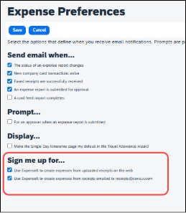
- Download the App (Android / iOS)
Use the Concur mobile app to capture or upload receipt images on the go.
- Review Resources
Check out the training materials and FAQs to get the most out of ExpenseIt.

If you have questions after reviewing the training materials, please contact your campus Concur administrator. We’re here to help make your expense reporting faster and easier!

