Reporting Options
Intelligence Reporting Access by Campus
- Management Access: All managers with Concur approval authority can access reports related to their department tree.
- Business Author: Each campus designates one business author (typically the Concur Travel & Expense lead) who can schedule reports.
- Report Consumer: One designated consumer per campus may access campus wide reports. Delegated access can be extended to up to two people, if necessary.
Note: Moving forward, the ProCard Administrator role may be considered for this designation where appropriate.
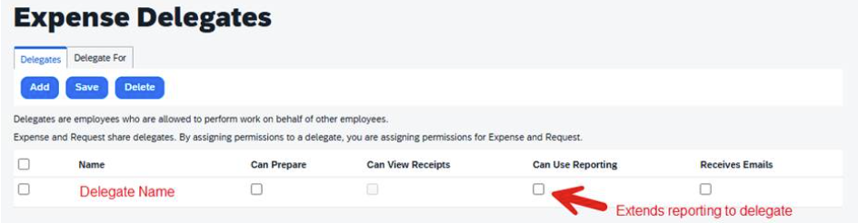
Campus-Wide Data Access Guidance
To enable others at your campus to view campus data:
- Report Scheduling: Ensures timely delivery of data to the intended audience. Reports can be scheduled by the Concur Travel & Expense Lead or by submitting a ServiceNow ticket (requires appropriate authorization).
- Delegated Access: Report consumer access may be delegated to another team member as needed by management with appropriate access.

Opportunity
This process offers campuses a chance to review and enhance procedures related to audit and compliance.

Outstanding Expense Dashboard Instructions
Summary
The Outstanding Expense Dashboard provides a snapshot of unclosed or pending travel-related cash advances, credit card transactions, and expense reports for the campus population managed by the person running the report.
Report Goal: Data from this report is used to process or resolve any records prior to calendar year 2025 and ultimately any transactions that exceed 60 days post travel.
Note, the age in days is defined in the prompt field.
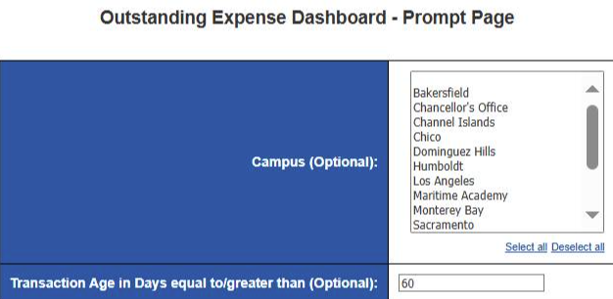
Running the Report
Concur Leads at the campus may schedule the report, as necessary, for management on campus needing to see the campus summary. The navigation for the original report within Concur Business Intelligence Reporting is in the path below.
Navigation: Team content > CSU Office of the Chancellor (p0034987uiwh) > Campus Reports
*Note: We recommend adding this report to the individual campus navigation path before scheduling for others.

Understanding the Report
The report has three sections to assist in transaction processing
- Cash Advances greater than 60 days post travel with balances
This section identifies cash advances that still display as outstanding. This dashboard will display the open report count and the total dollar amount. To see the detailed transactions that fit within this category, run the “Request - Cash Advance Balance” report (described just below each Chart Title).
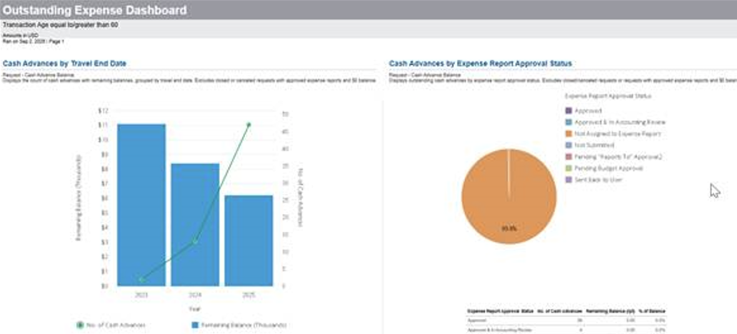
Example: The graph above reflects 2 remaining 2023 transactions valued at $11K and 13 2024 transactions valued at $8K. From the second chart, we can see most of these transactions are not on an expense report.
Action Needed: Concur Leads need to use the report and investigate the transactions to
  - determine the reason the transaction(s) have not yet been processed.
  - determine if there is a matching outstanding balance in the campus financial system.
  - work with travelers to resolve the issue.
  - Process report as appropriate to close the outstanding balance within Concur.
- Credit Card Transactions by Date and Approval Status
Credit Card Transactions by Date displays the count of card transactions by year with expense amounts for both active and inactive employees, excluding masked entries.
Credit Card Transactions by Approval Status reflects the report status for those remaining transactions.
To see the detailed transactions that fit within this category, run the “Expense - Accrual of Unassigned and Unpaid Credit Card Charges” report (described just below each Chart Title).
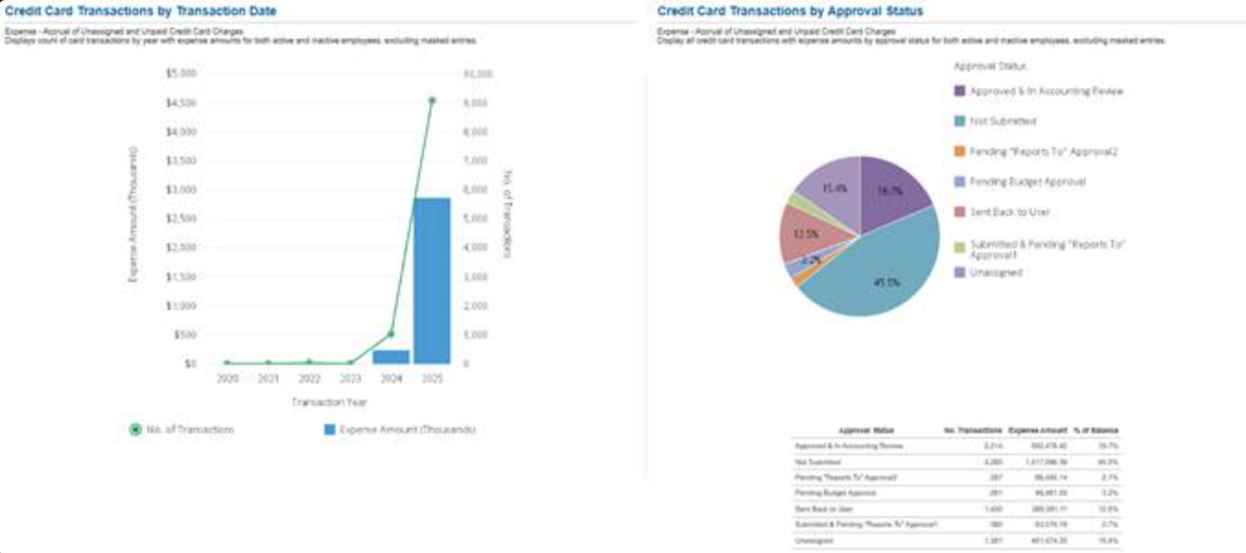
Example: The graph above reflects between 2-39 transactions remaining in each year between 2020-2023. The second chart displays the status of those transactions.
Action Needed: Concur Leads need to use the report to
- investigate transactions already on a report in any status, determine if the expense was already submitted/approved on another report by the user and if the credit card transaction was not added.
  - work with travelers to resolve the issue.
    - if the transactions are newer than 24 months, ensure the transaction is processed on a report. If a report has already been submitted, submit a supplemental report using the same name indicating it is a follow up. In the report purpose explain why a second report is being submitted.
    - if the transactions are older than 24 months and are on a report, the transaction will only be visible if it remains on the report. Once removed, it will no longer be visible to the traveler.
    - if the transactions are older than 24 months and are not on a report, they cannot be reconciled via Concur rather will need to be discussed with the accounting team on the campus to ensure the transactions have been reconciled appropriately.
  - resolve any outstanding items with the accounting team.
  - hide the outstanding credit card transaction within Concur so it doesn’t display in future or submit a Service Now ticket to hide the transaction(s).
Note: Airfare purchased more than 60 days prior to travel – may misrepresent the number of open transactions. Work with the traveler to ensure the transaction is on a report with a travel end date and this should resolve the issue.
- Expense Reports by Travel End Date and Approval Status
For both charts, displays expense reports for all statuses excluding “Approved.” The first chart is by report count and spend, the second is by approval status.
To see the detailed transactions that fit within this category, run the “Expense - Expense Reports with CF Information” report (described just below each Chart Title).
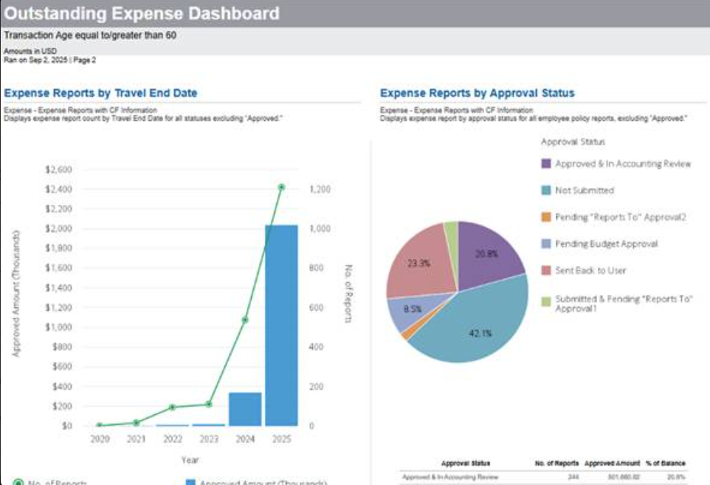
Example: There are many unsubmitted reports still open past the 60 day post travel mark and 42.1% have not been submitted.
Action Needed: Concur Leads need to use the report to
  - investigate why reports haven’t been submitted.
  - work with travelers to resolve the issue.
    - if the report is a duplicate or a test report and doesn’t need to be submitted, have the user delete the report.
    - if the report was previously submitted, work with the traveler and supervisor/approvers to
    - follow up and determine why the report hasn’t been resubmitted.
  - process remaining reports for payment.

