Concur Training Guide: Employee Reimbursement (Non-Travel)

Employee reimbursements for non-travel expenses apply to any out-of-pocket costs incurred by an employee that require reimbursement by the University. Examples include cell phone expenses, office supplies, materials, memberships, and similar purchases.

Step 1: Create a New Expense Report
- Log into Concur.
- Select Create New Report.
- Change the Report Type to: Employee Expense – Non-Travel
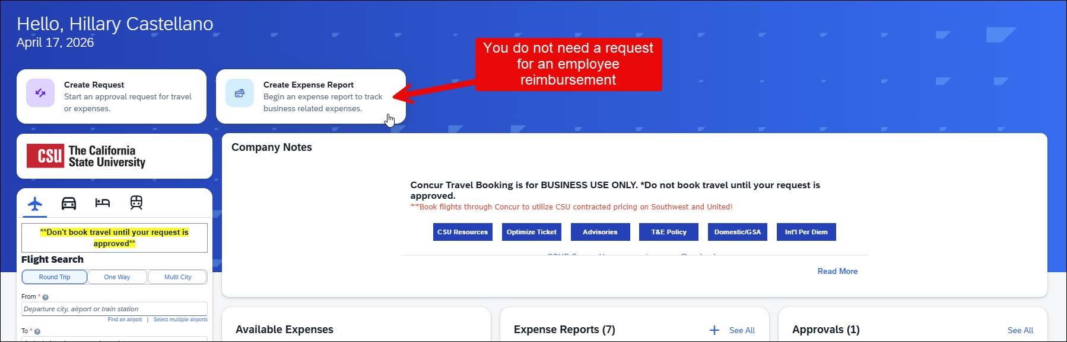
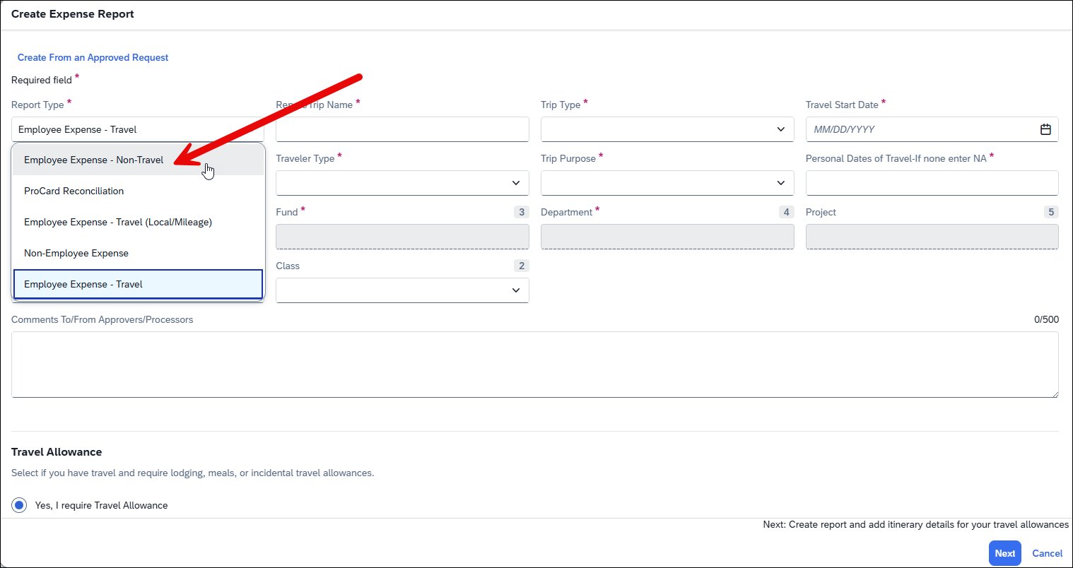
Step 2: Complete Report Details
- Fill out all required fields.
- Report Dates:
  - Ongoing expenses (e.g., monthly cell phone): Use the full date range the reimbursement covers.
  - One-time purchase: Use the same date for both start and end.
- Once complete, click Create Report.

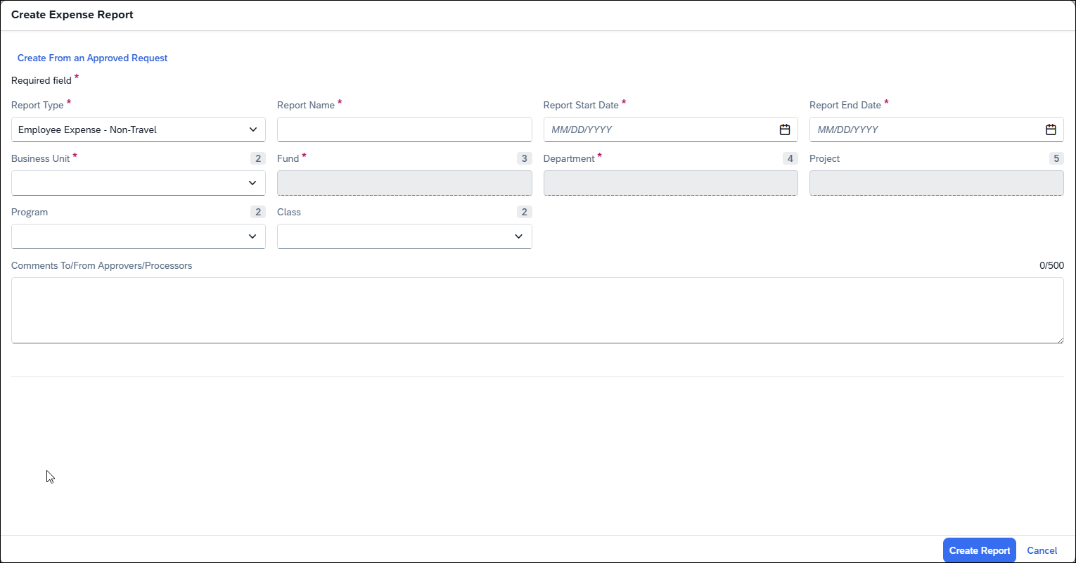
Step 3: Add Expenses
- Click Add Expense.
- Select the appropriate Expense Type:
  - Use Recent Expenses if applicable
  - Or search using the search bar
⚠️ Important:
Review the Concur expense types carefully to ensure you’re selecting the correct one for your department. (Reference: Concur Expense Type Availability)
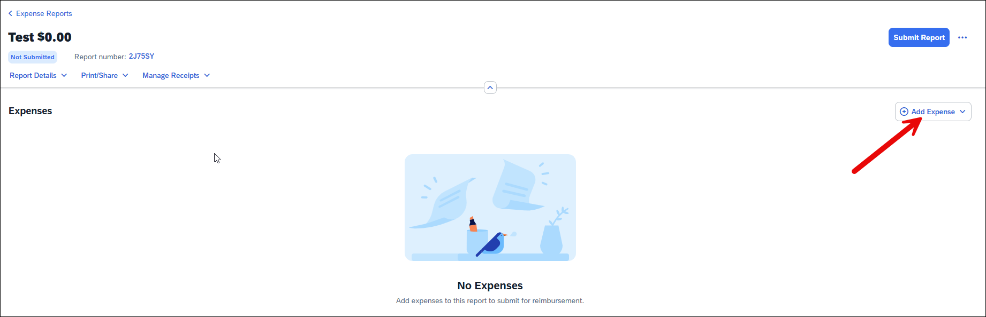
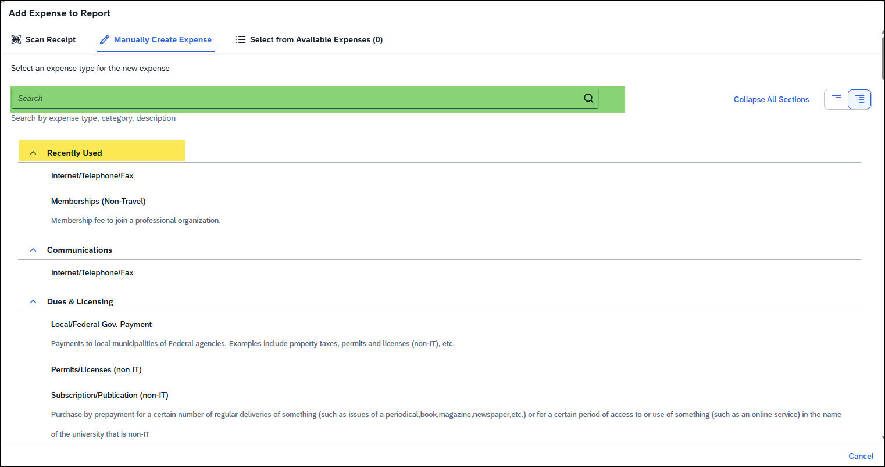
Step 4: Enter Expense Details
- For each expense:
  - Complete all required fields
  - Attach receipt(s)
  - Add comments if anything may need clarification (for approvers or Payment Services)
Step 5: Review Routing
- Before submitting:
  - Check the Report Timeline
    - Confirm it routes to your direct supervisor
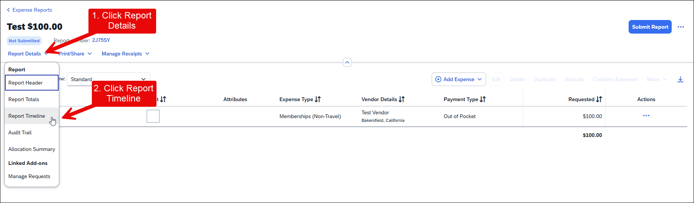
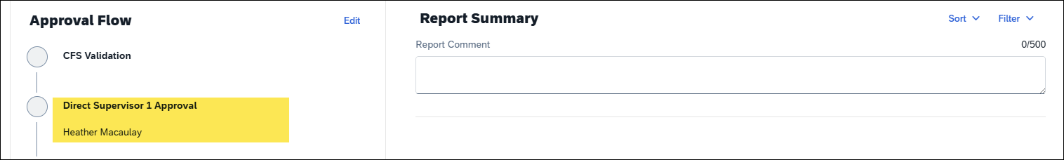
Step 6: Submit Report
- If everything looks correct: Click Submit Report

Additional Guidance
If you need to allocate expenses across multiple chartfields, refer to Concur User Guide.pdf

