Concur Delegate Functionality Training Guide
Overview
Delegates are employees who are authorized to perform work in Concur on behalf of another employee. This functionality helps maintain workflow continuity during absences or when administrative support is needed.
Expense and Request share delegate settings. When you assign permissions to a delegate, those permissions apply to both modules.
You may assign a temporary approver for up to 90 days.

How to Add or Update a Delegate
- Sign in to Concur.
- Select the Profile icon (top right corner).
- Click Settings.
- Select Expense Delegates.
- Click Add.
- Search for and select the employee.
- Choose the appropriate permission options.
- Save your changes.

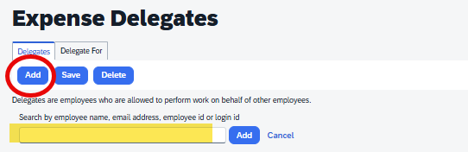

Delegate Permission Options Explained
Below is a breakdown of each available permission and what it allows the delegate to do.
1. Can Prepare
Allows the delegate to create and edit expense reports and requests on your behalf. This person cannot submit. Instead they click “notify” and it will need to be reviewed and submitted by the traveler.
Example: An administrative assistant prepares expense reports for a department chair.

2. Can View Receipts
Allows the delegate to view uploaded receipt images.
Important: This does not allow them to prepare or approve reports unless those permissions are also selected.

3. Can Use Reporting
Allows the delegate to run and access the same available Concur reports you can run.

4. Receive Emails
Allows the delegate to receive system-generated emails related to your Expense and Request activity.

5. Can Approve
Allows the delegate to fully approve documents on your behalf.
Important:
- The delegate must be an approved Delegation of Authority (DOA).
- When this permission is granted, the delegate replaces your approval authority during the delegation period.

6. Can Approve Temporary
Allows you to assign a temporary approver for a defined period (maximum 90 days).
This is typically used when you will be out of the office.
Important:
- The temporary approver must also have DOA approval.
- This person acts in your place during the specified timeframe.

7. Can Preview for Approver
Allows the delegate to review reports before they reach you for approval.
This permission does not allow them to approve. It is intended for review and quality control.
Example: A budget analyst reviews reports for compliance before the approving manager takes action.

8. Receives Approval Emails
Allows the delegate to receive notifications when documents are submitted for your approval.

Important Reminders
- You cannot assign someone as a delegate with approval authority unless they have an approved DOA.
- A delegate with approval permissions replaces your approval action during the delegation period.
- Delegate permissions apply to both Expense and Request.
- Temporary approval assignments cannot exceed 90 days.

Best Practices
- Only assign the minimum permissions necessary.
- Review delegate settings regularly.
- Clearly communicate roles when assigning approval authority.
- Remove temporary delegates promptly after the delegation period ends.
- If you need to add someone to the workflow as a secondary or tertiary DOA, you need to fill in a Chartfield Request Form for Accounting to update.

