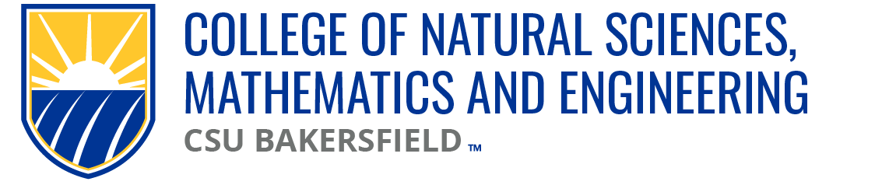

NSME Curriculum Committee Meeting Minutes
Date: Friday, November 1, 2024 | Time: 10:03a

Present:
Linh Bui (PH), Brian Ryals (MATH), Sarah Forester (CHEM), Tat Acharya (P&E), Denise Gilliland (NURS), Cark Kloock (BIOL), Anthony Rathburn (GEOL)

Karlo Lopez (Dean’s Office)
Maria Chavez (Admin Support)

Absent: Alberto Cruz (CEE/CS)
Chris Krugh (GEOL) | Anthony Rathburn in place of Chris Krugh

Meeting Minutes:
10.25.24 |Approved

Approval of Agenda:
11.01.24 | Approved

Old Business
Cal-GETC update | all departments approved.
K. Lopez to present to the chairs next week.

Nursing Course Proposals Update | Next week, BSN program submissions to be submitted

Public Health Course Proposals Update | currently waiting on KINE memo and updating forms.

CEECS MS in Computer Science | Second Reading postponed to 11.08.24

New Business
CEECS BS in Computer Information Systems
CEECS Course Proposal Forms
CMPS 1770
CMPS 2690
CMPS 3110
CMPS 3550
CMPS 3610
CMPS 3640
Postponing to 11.08.24

Open Forum:
BIOL | marked up and clean copy of complete catalog to be submitted to NSME CC.

Next meeting: 11.08.24

Adjourn: 10:20p

