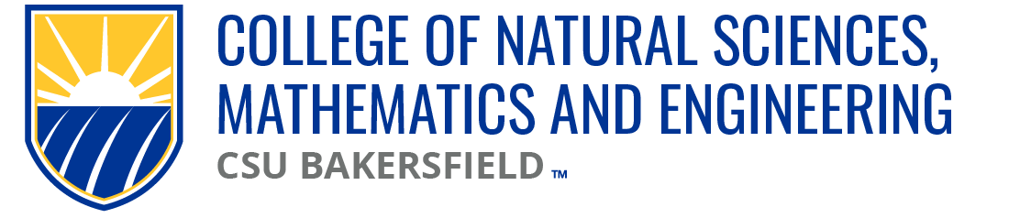

NSME Curriculum Committee Meeting Minutes
Date: Friday, October 4, 2024 | Time: 10:04a

Present:
Alberto Cruz (CEE/CS), Linh Bui (PH), Sarah Forester (CHEM)
Brian Ryals (MATH), Denise Gilliland (NURS), Tat Acharya (P&E)
Cark Kloock (BIOL), Chris Krugh (GEOL)

Karlo Lopez (Dean’s Office)
Maria Chavez & Emely Silva (Admin Support)

Meeting Minutes:
09.27.24 | Meeting minutes approved

Approval of Agenda:
10.04.24 | Approved

Old Business
Catalog Deadline for NSME Curriculum Committee
Tentative | Proposed February 15th submission deadline for Cal-GETC to be incorporated into deadline

Sciences depts proposing BIOL offering 1 four-unit course that has lab incorporated
Sciences chairs to decide by Monday, October 7th RE: BIOL proposal of four-unit course w/ lab incorporated & the physical sciences offering 3 unit courses

NSME CC Submission deadline to be discussed by this committee on 10.11.24

BIOL 4370
Approved w/ the condition of Course Repetition section to be updated.

New Business
CEE/CS Submission
Mechanical Engineering Program Proposal to add to the master plan approved
NSME CC Chair to send memo to Tat Archarya of CC approving
Open Forum:
Cal-GETC catalog updates | AO to supply language to incorporate into catalog updates, hopefully before November.
10.18.24 | B. Ryals out, S. Forester to step in to run the CC meeting

Next meeting: 10.11.24

Adjourn: 10:33a

