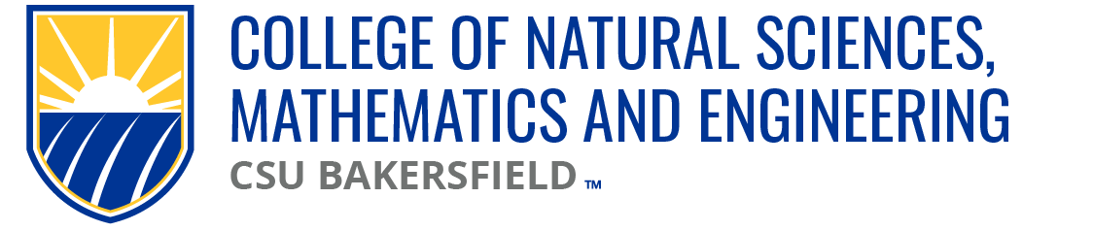

NSME Curriculum Committee Meeting Minutes
Date: Friday, September 27, 2024 | Time: 10:00a

Present:
Vincent On (CEE/CS), Linh Bui (PH), Sarah Forester (CHEM)
Brian Ryals (MATH), Denise Gilliland (NURS) (ZOOM), Tat Acharya (P&E)
Cark Kloock (BIOL), Chris Krugh (GEOL)

Karlo Lopez (Dean’s Office)
Maria Chavez & Emely Silva (Admin Support)

Absent
Alberto Cruz (CEE/CS) | Vincent On attended for CEE/CS

Meeting Minutes:
09.20.24 | Meeting minutes approved

Approval of Agenda:
09.27.24 | Approved

Old Business
CMPS 5020
NSME CC approved 9.27.24p
Karlo emailed AO RE: CMPS Course Catalog AY24/25 updates, waiting on confirmation of updates from AO

New Business
Biology Submission
BIOL 4370 New Course Proposal
Approved for 1st reading

Open Forum:
January 31st (assumed) | catalog submissions due to academic operations (AO)
K. Lopez Proposal | NSME CC to complete approvals by December. Dept reps to take it back to departments and decide 10.04.24
CAL-GETC? | Discussion over additional science GE unit requirement will be accommodated Karlo to arrange meeting w/ E. Montoya w/ science dept chairs regarding this new GE requirements.

Next meeting: 10.04.24

Adjourn: 10:31a

