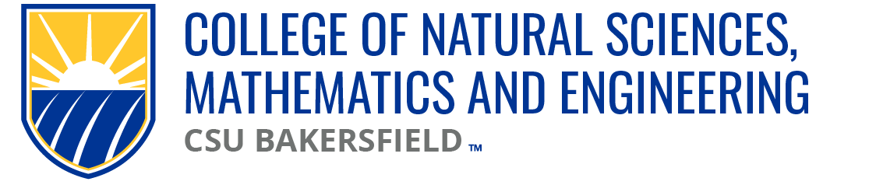

NSME Curriculum Committee Meeting Minutes
Date: Friday, September 20, 2024 | Time: 10:00a

Present:
Alberto Cruz (CEE/CS), Linh Bui (PH), Sarah Forester (CHEM)
Brian Ryals (MATH), Denise Gilliland (NURS), Tat Acharya (P&E)
Cark Kloock (BIOL) (ZOOM)

Karlo Lopez (Dean’s Office)
Maria Chavez (Admin Support)

Absent
Chris Krugh (GEOL)

Meeting Minutes:
09.06.24 | Meeting minutes approved

Approval of Agenda:
09.20.24 | Approved

Old Business
Deadlines and procedures for submissions
Submissions to be funneled through each department representative in the CC

New Business
CMPS Submission
CMPS 5020 New Course Proposal & Syllabi
Question on why “YES” | Course Repetition Section – “Allow multiple enrollments in the same term?”
CMPS 5020 1st reading approved

Open Forum:
Any submissions that did not take from last year, resubmit via ServiceNow.
Karlo to follow up w/ AO RE: CMPS Course Catalog AY24/25 updates that did not take

Next meeting: 09.27.24

Adjourn: 10:34ap

