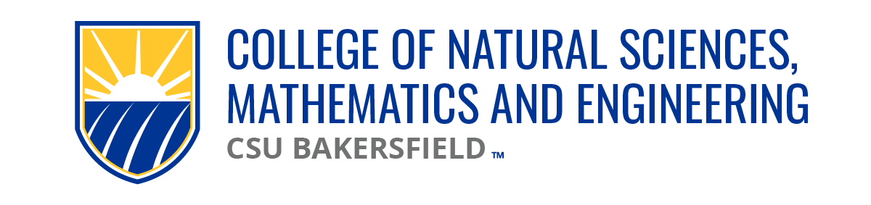

NSME Curriculum Committee Meeting Minutes
Date: Friday, September 6, 2024 | Time: 10:00a

Present:
Vincent On (CEE/CS), Linh Bui (PH), Cark Kloock (BIOL), Chris Krugh (GEOL)
Brian Ryals (MATH), Denise Gilliland (NURS), Tat Acharya (P&E)

Karlo Lopez (Dean’s Office)
Maria Chavez (Admin Support)

Absent
Alberto Cruz (CEE/CS) | Vincent On attended for CEE/CS
Sarah Forester (CHEM)

Approval of Agenda:
No agenda

Meeting Minutes:
04.30.24 | Meeting minutes approved

New Business
Committee nominates B. Ryals Chairs| Approved 10:06a

Old Business
CEECS - SCI 3219 | Pending confirmation of unit count (should be 3 units) before routing for signatures. Confirmed.
To be routed |previously approved NURS 3190 revision form
BIOL 4918 revision | Approved 10:22a
Will be routed and submitted to GECCO

Submission Deadline to this committee is November 18th

Updates from K. Lopez:
Submission process same as past year
B/C of CAL GETC, deadline for GE submissions has been pushed out
December 1st deadline still stands (November 29th)
K. Lopez confirmed w/ E. Montoya | For GE changes, GE Form needs to be submitted with the catalog changes

Open Forum:
Action Item – AY24-25 NSME CC Chair, A. Bianchi | B. Ryals to confirm 23/24 AY NSME CC report to academic affairs
Next meeting:
9/13/24 | 10am

Adjourn: 10:25a

