Meeting Information
Meeting Title: RunnerCard Committee | Date: Thursday, September 19, 2024
Location: ITS Silver Room - Zoom Conference Call  Meeting URL: https://csub.zoom.us/j/85892660349?pwd=d17u3kH3yAv9jpRxXyvoQaBHKPuX8T.1&from=addon  Meeting ID: 858 9266 0349  Passcode: 283071 | Time: 3:30pm – 4:30pm
Meeting Called By: Richard Nelson | Purpose: Quarterly Meeting – Q3 2024

Attendees
Checkmark or “X” indicates the attendee is present
Attendee | Representing | X
Rich Nelson  (Chair) | ITS – Runner Card Service Owner | X
Matthew McCoy | Assistant Librarian
Heather Macaulay | Univ. Controller – AVP/CAO
Mike Brown | AV – IT Consultant
Erin Pruitt | ASI President | X
Hilda Nieblas Valenzuela | Housing – Director
Lourdes Hernandez | Housing – Coordinator | X
Rubicelia Alvarez | Student Involvement - Director | X
Steve Miller  (1/2 vote) | ITS – RunnerCard DBA
Christian Ortiz  (1/2 vote) | ITS – RunnerCard DBA
Cindy Goodmon (Advisory) | Athletics - Director
Mari Gonzalez  (Advisory) | UPD – Chief | X
Greg Kinder  (Advisory) | UPD – Lieutenant | X
Aditi Arya  (Advisory) | Facilities – Manager | X
Adriana Van Grinsven  (non-vote) | ITS – Accounting Technician | X
Ydalia Lucio  (non-vote) | ITS – Administrative Support | X

Agenda
# | Agenda Topic | Led By | Time Allotted
 | Call to Order | R. Nelson | 1 minute
 | Approval of Minutes – February 2024, Meeting | R. Nelson | 1 minute
 | Announcements and Information | R. Nelson | 7 minutes
 | Approval of Agenda | R. Nelson | 1 minute
 | Old Business  - Library/ACS Access Control Project update  - RunnerCard Policy update | R. Nelson  R. Nelson | 25 minutes
 | New Business  - Review, amend, approve proposed budget  - Mobile Credential Proposal | R. Nelson  R. Nelson | 25 minutes

RUNNERCARD COMMITTEE MINUTES
September 19, 2024 | 3:30 PM – 4:30 PM
Silver Conference Room and Zoom Conference

ATTENDANCE: Rich Nelson, Information Technology Services
Lourdes Hernandez, Housing Director
Rubicelia Alvarez, Student Affairs Director
Erin Pruitt, ASI President
Steve Miller, RunnerCard Database Administrator
Mari Gonzalez, UPD Chief
Greng Kinder, UPD Lieutenant
Aditi Arya, Facilities Manager
Adriana Van Grinsven, ITS – Accounting Technician
Ydalia Lucio, Administrative Support

A quorum was not established.

      - Call to Order: Meeting was called to order at 3:43 PM by Rich Nelson.

      - Approval of Minutes: No minutes to approve.

      - Announcements and Information: AI features on Zoom provided to attendees for knowledge of feature.

      - Approval of Agenda: No quorum to approve agenda.

      - Old Business:
- Library/ACS Access Control Project update
The project to upgrade the door readers to a new system was piloted with the ITS team and was placed on hold to review and address challenges: data migration and mechanisms issues. When implementing campus wide things to consider will be cards issued 2019-current should be ok, cards issued between 2018-2019 may need to be reprogrammed, and cards issued prior to 2018 do not have the proper reader and will need to be replaced. The project will restart this coming Monday and should take only a week and half left to complete. The library’s 24- hour door will be locked and will be accessible via a badging system to access the study room. This increase security measures by ensuring access to enter.
- RunnerCard Policy Update
The policy update is to provide corrections on updated information. The information updated on the policy are:
- Procedures for lost or stolen cards
- Where to go if technical card issues arise
- Where to go to add funds to your card

      - New Business:
- Review, amend, approve proposed budget
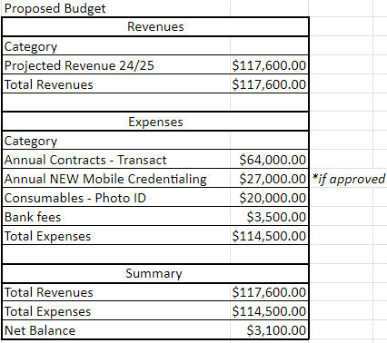
ACTION: Quorum was not met and email requesting a vote will be sent out by Rich. Voting members at the meeting approved moving forward with the budget.
- Mobile Credential Proposal
Transact Mobile Credential is a digital ID solution designed primarily for higher education institutions. Students can use their smartphones or smartwatches as their student ID cards. The credentials are stored in NFC-enabled wallets like Apple Wallet, Google Wallet, and Samsung Wallet. Students can use their mobiles devices to enter buildings, pay for meals, access vending machines, and more. The system uses secure technology to prevent identity theft and fraud. Students will no longer need to carry ID cards, reducing the risk of losing them. The system allows for faster transactions and easier access to campus facilities. This solution helps eliminate plastic cards and reduce waste. In addition, the digital IDs are more secure than traditional physical cards needing a multifactor authentication and cannot be easily replicated. Several campuses have adopted the Transact Mobile Digital ID to enhance campus experience. A couple of campuses that have implemented this are Northeast Mississippi Community College and Penn State. Below are links for each of their feedback on their experience.

            - NEMCC onboarded Transact Campus ID solutions for higher ed to streamline their student ID program
            - Transact Penn State

Cost for Project: $55,230.50
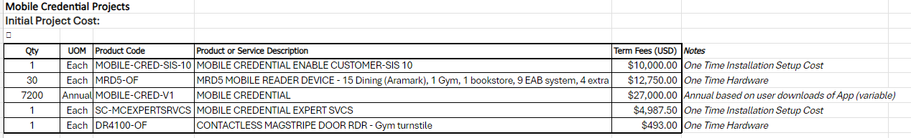

Approval of this project is needed as soon as possible due to deadlines. Voting members at the meeting approved moving forward with the Mobile
Credential.
ACTION: Rich will send an email out to the committee to obtain vote on absent voting members.
ACTION: Rich will reach out to vendor and inquire how card access would work with someone who has a Watch Phone and a Mobile Phone.

      - Adjournment: Meeting adjourned at 4:29 PM.

