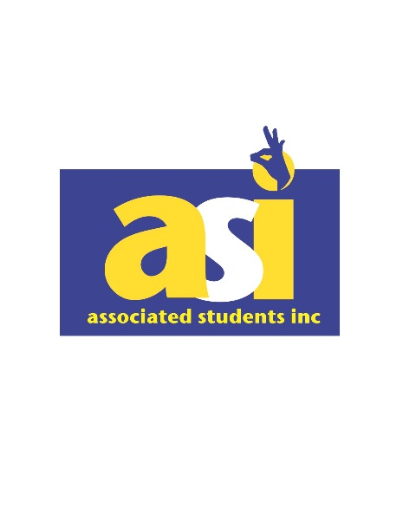

**Associated Students Incorporated**

**California State University, Bakersfield**

56 SU

9001 Stockdale Highway

Bakersfield, CA 93311-1002

[http://www.csub.edu/asi](http://asi.csub.edu/)

P: (661) 654-2418

**ASI Funding Policy for Student Groups**

Associated Students Incorporated is your student government, and one of ASI's main goals is to improve campus life by offering funds to our student clubs and organizations. We believe that student groups are fundamental in accomplishing this goal. Student groups that follow the guidelines below may qualify for ASI funds.

All funds given out by ASI that involve ASI reallocating mandatory student association fees for viewpoint expressive events will use viewpoint neutrality. Viewpoint Neutrality is a process in which all funding or allocation decisions governing the allocation of mandatory student association fees are made pursuant to narrow, objective, and definite standards, and which does not involve the exercise of judgment or formation of an opinion concerning the content of the event, or is otherwise affected in any way by the viewpoint of a student organization or the proposed event.

Viewpoint Neutral Funding is a process in which all funding or allocation decisions are made pursuant to narrow, objective, and definite standards, and which does not involve the exercise of judgment or formation of an opinion concerning the content of the event, or is otherwise affected in any way by the viewpoint of a student organization or the proposed event. A club/organization applying for funds that involve ASI reallocating mandatory student association fees for viewpoint expressive events cannot be granted or denied funding on the basis of its viewpoint or because it advocates a particular opinion or view. Funding decisions must be based on procedures and criteria that are not tied to the viewpoint expressed by the club/organization or the approval, disapproval, acceptance, or rejection of that viewpoint.

**Funding Guidelines**

* Clubs/organizations applying for funds must be completely chartered and in good standing with the Office of Student Involvement.
* Only Club Presidents or Treasurers may submit the ASI Funding Application
* **Funding applications must be submitted to ASI no less than two (2) weeks if requesting less than $1,000.00 or four (4) weeks if the request is greater than $1,000.00, prior to the event.**
* Organizations must provide a detailed description of the event, including a detailed budget on how funds will be used, and any other relevant details.
* Misrepresentation or use of funds for any activity not disclosed in the ASI Funding Application will result in sanctions on current and future allocations.
* Funds are allocated on a “first come, first serve” basis, as long as funds are available: A maximum of $3,000 per year per club/organization is allowed.
* All student organizations must provide a minimum 10% financial investment when applying for funding.
* Events/activities must be held on campus, be open to all students, and be free-of-charge. Graduation ceremonies/receptions will not be funded.
* Club clothing, personal gifts, raffles, opportunity drawings, prizes, awards, insurance, and basic operational (subscriptions, club items) costs will not be funded.
* Clubs are allowed up to $500 in travel expenses that will be deducted from the annual $3,000 maximum per year. If the club requests over $500, their funding application will have to be presented and approved by the Board of Directors for a maximum of $1000.
  + Traveling will not be funded unless there is an educational, cultural or club-related value.
  + Traveling must follow current CSUB campus guidelines.
* Within fourteen (14) days of the conclusion of the event, the club will be expected to submit the ASI Funding Post-Event Form. Failure to submit the form within fourteen days without informing the ASI VP of Finance will result in a 10% reduction of their next funding request. .
  + The approved amount cannot be transferred to the club’s account until the Post-Event form is submitted.
  + Additional ASI funding requests cannot be made until the Post-Event Form is submitted.
* The Post-Event Form includes a student attendance list, expense report, and assessment of the event. Incomplete ASI Funding Applications will be rejected and must be re-submitted as a new application.

**Student Leadership Council**

* One club president, vice president or treasurer from each student club/organization must attend all Student Leadership Council Meetings. If a representative is unable to attend or send any other member of the club, they must notify ASI VP of Finance or ASI President two (2) days prior to the meeting to make arrangements.
* If a club/organization misses Student Leadership Council meetings without contacting the ASI VP of Finance, the club will be deducted an extra 10% per missed meeting for any future funding requests.
* The 10% deduction can be earned back by attending the next Student Leadership Council meeting.
* One student officer is able to represent only one club/organization at the Student Leadership Council.

**Processing**

* The ASI Vice President of Finance will contact your club with a time, date and place for a representative of your club to appear before the ASI Finance Committee at its regular business meeting to go over your request and have you answer any questions.
* After appearing before the ASI Finance Committee, the representative will be dismissed and the Committee will discuss the request and agree upon an amount. The club will be notified of the funding decision, and any funds if approved will be deposited directly into the club's on-campus account after the Post-Event Form is completed.
* If the funding request exceeds $999.99, the procedure will take an additional week, as a representative of the club will also be asked to appear before the ASI Board of Directors before a decision regarding funding will be made.
* If the club is dissatisfied with the amount of funding awarded by the ASI Finance Committee, it may file an application for reconsideration appeal to the ASI Board of Directors. At the next ASI Board of Directors meeting, the ASI Board of Directors must approve or deny the application for reconsideration and deliver their decision in writing via electronic communication to the person that submitted the application on behalf of the club. If the application satisfies the criteria set forth above in the “Funding Guidelines” and mandatory student association funds are available, the ASI Board of Directors must approve the application as submitted. If the ASI Board of Directors denies the application or decreases the original funding request amount, the ASI Board of Directors must (1) issue their decision in writing to the club, and (2) identify the specific reasons for the denial or reduction.
* If the club disagrees with the decision of the ASI Board of Directors regarding the application for reconsideration because the ASI Board of Directors violated or did not comply with the viewpoint neutrality requirements herein, the club may appeal and request a meeting with the Vice President of Students Affairs or his/her designee within three (3) business days of receipt of the decision.
  + The appeal must be in writing and state the reason(s) that the club believes the funding application was wrongfully denied or reduced. The appeal shall be limited to the question of whether the application was properly denied pursuant to the policy or whether viewpoint or opinion played an impermissible role in the denial or reduction.
  + The meeting shall take place within ten (10) business days of the request.
  + At the meeting, the parties will discuss the application and the Vice President of Students Affairs or his/her designee shall explain his/her reasons for any reduction in amount or denial of the appeal.
  + The club will receive written notice of the Vice President of Students Affairs or his/her designee’s decision within ten (10) business days after the meeting.
  + If the decision confirms the denial of or decrease in funding, the decision will explain and state in writing the reasons why the funding was denied or decreased.
  + The VPSA or the VPSA’s designee shall determine “de novo” (i.e., without any deference to the ASI Board of Directors’ decision) whether the funding decision complied with the terms of the policy or whether it violated the viewpoint neutrality requirement.

Revised: 2.14.25